Lab Assignment 5
Stepan Shkrobak
Dr. Michael Bartolacci
IST 894, Section 001: Capstone Experience,
1 March 2026

Table of Contents
Table of Contents 1
General Context 2
Technical Context 3
Screenshots 4
References 12

General Context
The Advanced Adversary Attack Tactics Cyber Range, specifically Reconnaissance and Resource Development and Pivoting with Proxychains, focused on initial access preparation and post-compromise lateral movement. The first lab focused on reconnaissance as a structured intelligence gathering process, where, rather than exploiting technical vulnerability immediately. It showed how attackers collect publicly available information to build credibility and knowledge before launching a phishing or credential harvesting campaign. This is a representation or real world adversary behavior, which is part of the cyber kill chain model, where reconnaissance and resource development are significant in influencing successful attacks. Industry reports continue to show that social engineering and credential compromise remain dominant breach vectors, reinforcing the importance of understanding how attackers weaponize publicly accessible information (IBM Security 2023).

The Pivoting with Proxychains lab focused more on the post compromise, specifically network pivoting and traffic tunneling. It showed how an attacker, once they gain access to one system, can leverage it as an intermediary to reach other protected internal assets. It directly covers lateral movement and command-and-control techniques outlined in the MITRE ATT&CK framework (MITRE, 2023). It emphasises how perimeter security alone is not enough, and organizations must include segmentation and detection for anomalous proxy behavior. The lab also showed how encrypted SSH tunnels and SOCKS proxies can obscure the true origin of traffic, making malicious activity appear as though it is coming from a trusted internal host.

In the Reconnaissance and Resource Development lab, cewl -n -e --email_file=./emails http://target/login was used to collect email addresses, and then gobuster dir -w /usr/share/seclists/Discovery/Web-Content/common.txt -u target/ -x "txt,md" found hidden directories such as /downloads and /news. Then, using the Social Engineering Toolkit, cloned the login page to capture submitted credentials, which simulated the credential harvesting. The Pivoting with Proxychains lab had us use nmap -p- pivot to identify exposed services, followed by ssh -f -N -D 9050 root@pivot -4 to establish a SOCKS proxy tunnel. After configuring ProxyChains to use 127.0.0.1 9050, the commands proxychains4 nmap -Pn -sT target and proxychains4 firefox were run to access otherwise unreachable internal systems, illustrating practical lateral movement and tunneling techniques.

Technical Context
Reconnaissance and Resource Development and Pivoting with Proxychains, focused on initial access preparation and post-compromise lateral movement. The first lab centered on reconnaissance as a structured intelligence gathering process, where, rather than exploiting a technical vulnerability immediately, the objective was to collect publicly available information to build credibility and operational knowledge before launching a phishing or credential harvesting campaign. Commands such as cewl -n -e --email_file=./emails http://target/login were used to extract email addresses directly from the target site, and gobuster dir -w /usr/share/seclists/Discovery/Web-Content/common.txt -u target/ -x "txt,md" identified hidden directories like /downloads and /news. This represents real-world adversary behavior consistent with the cyber kill chain model, where reconnaissance and resource development significantly influence the likelihood of a successful attack. Industry research continues to show that phishing and compromised credentials remain dominant initial access vectors, reinforcing how attackers weaponize exposed information (IBM Security, 2023), and these risks align with security misconfiguration issues identified in the OWASP Top Ten (OWASP Foundation, 2021).

The Pivoting with Proxychains lab focused more on the post compromise phase, specifically network pivoting and traffic tunneling. It demonstrated how, once access to a single system is obtained, that system can be leveraged as an intermediary to reach additional protected internal assets. The lab used nmap -p- pivot to enumerate services, followed by ssh -f -N -D 9050 root@pivot -4 to establish a dynamic SOCKS proxy tunnel. After configuring ProxyChains to use 127.0.0.1 9050, commands such as proxychains4 nmap -Pn -sT target and proxychains4 firefox allowed access to systems that were not directly reachable. This directly reflects lateral movement and encrypted command-and-control techniques outlined in the MITRE ATT&CK framework (MITRE, 2023). It emphasizes that perimeter security alone is insufficient, and organizations must implement internal segmentation and monitoring controls.

The two labs overall covered reconnaissance, credential harvesting, SSH tunneling, and proxy-based routing, showing how it can all be chained together into an adversary attack workflow. From collecting emails and cloning a login page with SET to pivoting traffic through encrypted tunnels, we saw how limited initial access can expand into broader internal compromise. Federal guidance from NIST highlights the importance of firewall policy and internal network controls to limit such movement (NIST, 2009), and CISA guidance further stresses detection of lateral movement and anomalous proxy behavior within enterprise networks (CISA, 2022). Together, these labs reinforce the need for layered defensive strategies that address both exposed public information and internal network visibility.

Screenshots
Reconnaissance and Resource Development
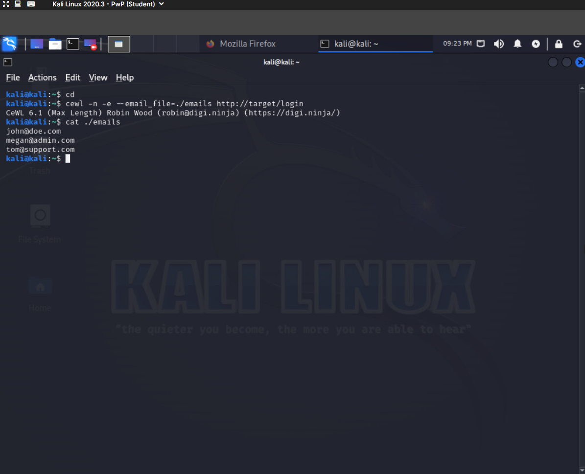

Exploring Hidden Directories for Valuable Information
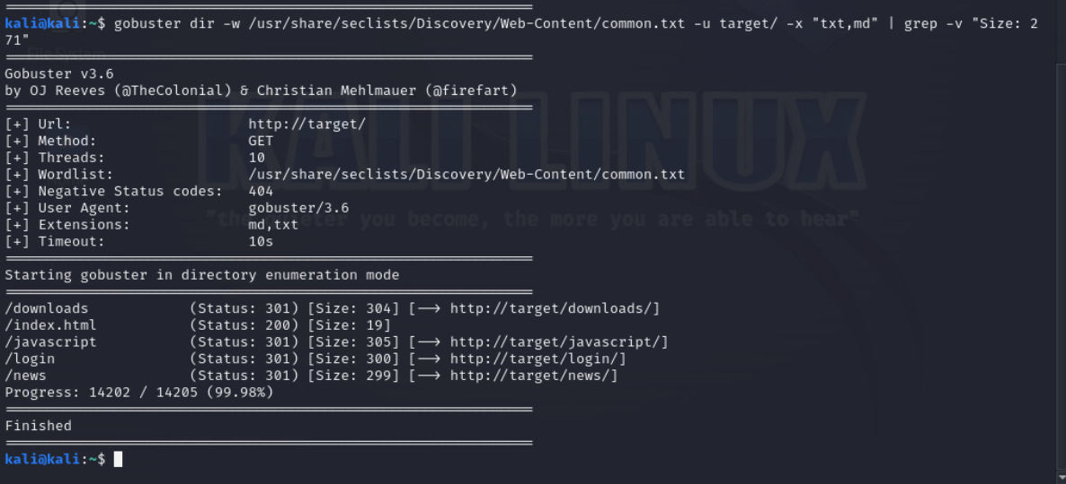

Exploring Hidden Directories for Valuable Information
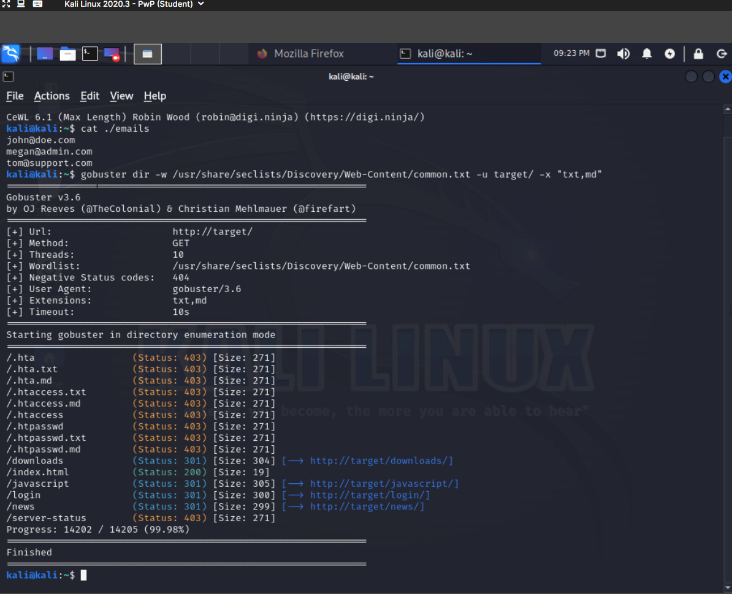

Cloning a Website for Credential Harvesting with SET
Conclusion - Post clicking Login button on http://localhost page
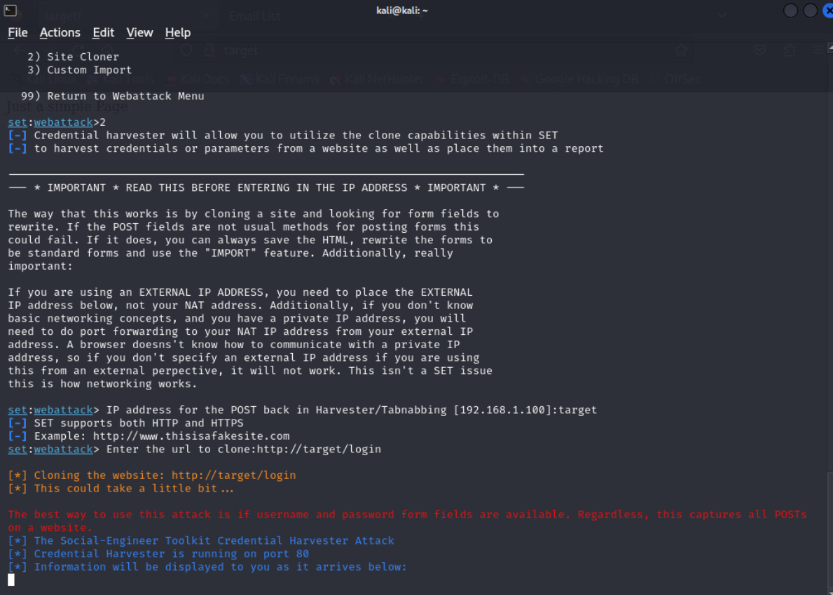

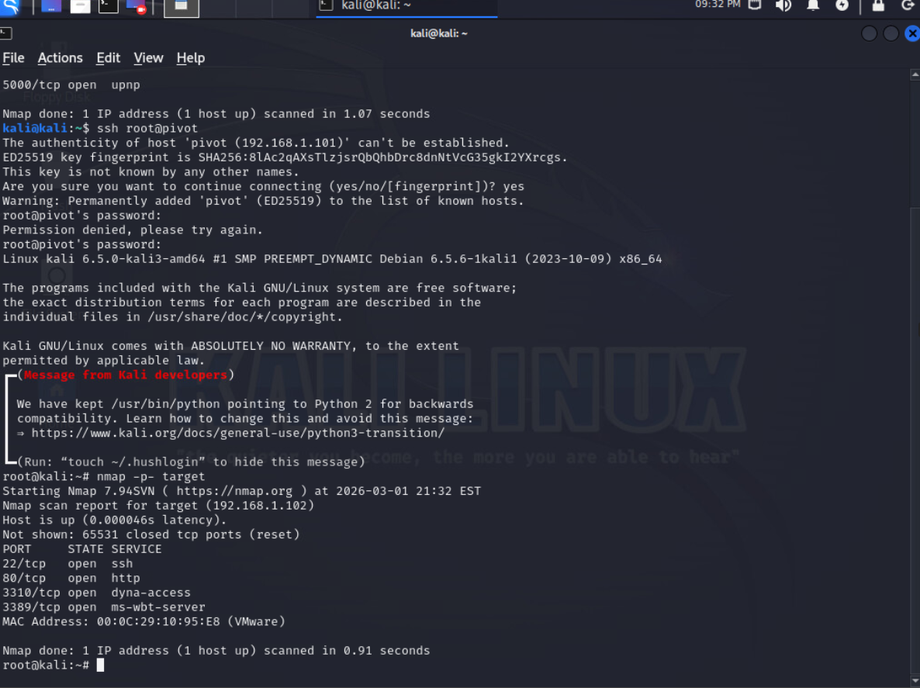
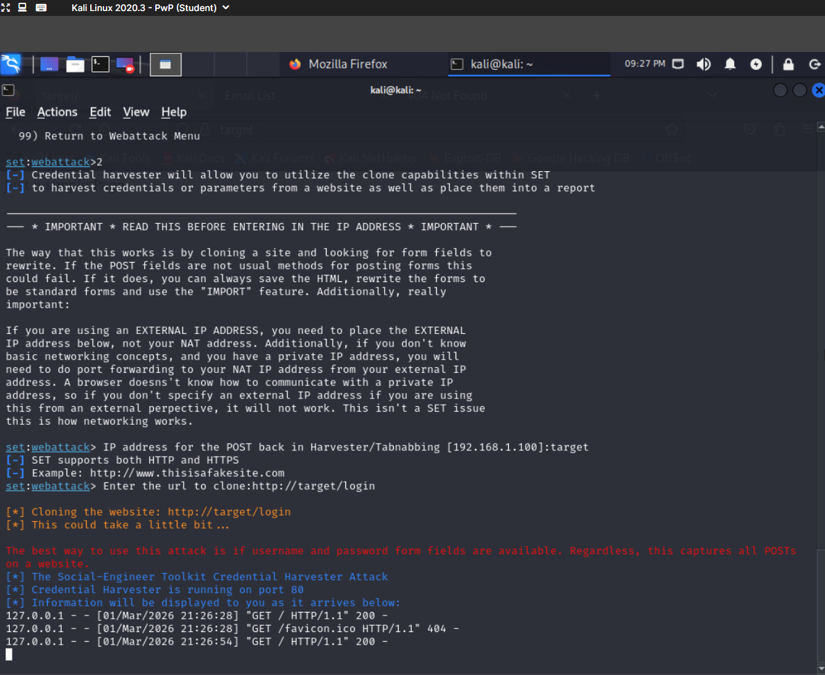

Pivoting with Proxychains


Setting Up Proxychains for Target Interaction
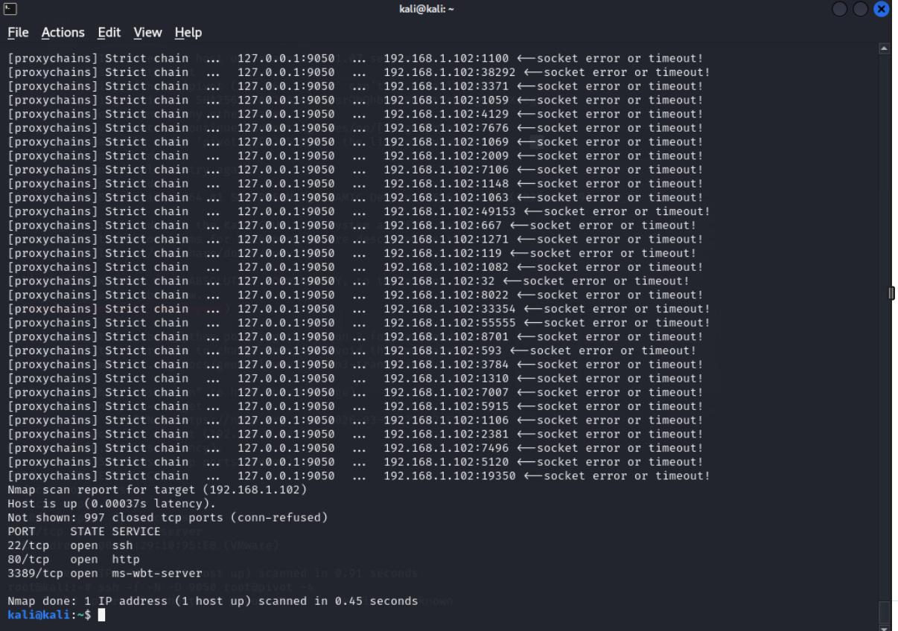

Using Proxychains with Multiple Layers
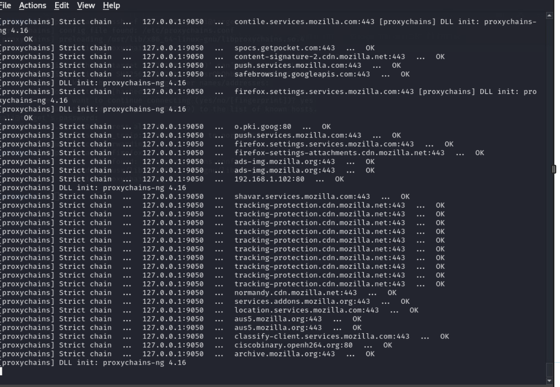

Lab Completions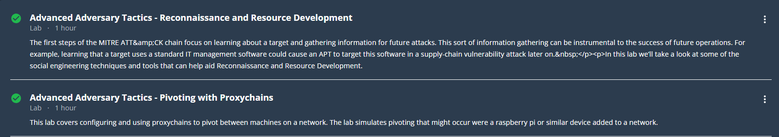

References

IBM Security. (2023). Cost of a data breach report 2023. IBM. https://www.ibm.com/reports/data-breach

National Institute of Standards and Technology (NIST). (2009). Guidelines on Firewalls and Firewall Policy (SP 800-41 Rev. 1). https://csrc.nist.gov/publications/detail/sp/800-41/rev-1/final

MITRE. (2023). MITRE ATT&CK®: A knowledge base for adversary tactics, techniques, and procedures. https://attack.mitre.org

Cybersecurity and Infrastructure Security Agency (CISA). (2022). Eviction strategies tool & lateral movement detection guidance. https://www.cisa.gov/eviction-strategies-tool

OWASP Foundation. (2021). OWASP Top Ten Web Application Security Risks. https://owasp.org/www-project-top-ten/

